
Company
Logotype

Cone Beam Computed Tomography- Report



Porur Dental X-rays & CBCT

Patient Name : Mr. Vijaykumar | Date of Report : 18.06.2025
Age/ Gender : 71 years/ Male | Region of Interest : CBCT Full Skull
Referring doctor: Dr. Selva Ganesh | Indication : Implant assessment
Clinical Notes: Nil
PATIENT INFORMATION

CBCT- Full Skull provided
CBCT – IMAGE DETAILS

RADIOGRAPHIC INTERPRETATION

- The maxillary arch is present with 4 nos of hyperdense screw like structures (implants) in the following regions: 11, 12 region, 14, 15 region, 22, 23 region, 24, 25 region. Hyperdense structure connection the 4 implant structures is evident above the al
- The mandibular alveolar ridge is present with 4 nos of hyperdense screw like structures (implants) in the following regions: 33, 34 region, 43, 44 region.
- The alveolar ridge in relation to the maxillary and mandibular alveolar ridge is present with multiple areas of sclerotic changes.
- Root stumps present in relation to 17, 47

IMPLANT ASSESSMENT

 | 15 region | 16 region | 17 region | 25 region | 26 region | 27 region
Sub-Crestal (in mm) | 6.5 | - | - | - | - | -
Mid- Crestal (in mm) | - | - | - | - | - | -
Distance between the alveolar ridge and floor of the maxillary sinus (in mm) | 4.7 | 3.3 | 3.3 | 2.5 | 1.2 | 1.4

 | 35 region | 36 region | 37 region
Sub-Crestal (in mm) | 7.3 | 8.9 | 11.2
Mid- Crestal (in mm) | 9 | 11.3 | 13.4
Distance between alveolar ridge and the inferior alveolar nerve canal (in mm) | - | 14.6 | 13.5
Distance between alveolar ridge and the inferior border of mandible (in mm) | 28.9 | 27 | 24.9

 | 45 region | 46 region | 47 region
Sub-Crestal (in mm) | 7.1 | 9.5 | 8.5
Mid- Crestal (in mm) | 8.7 | 11.6 | 11.5
Distance between alveolar ridge and the inferior alveolar nerve canal (in mm) | 15.8 | 15.8 | 17.5
Distance between alveolar ridge and the inferior border of mandible (in mm) | 29.3 | 28.2 | 27.4

RADIOGRAPHIC IMPRESSION

- Partially edentulous maxillary and mandibular arch.
- Root stumps: 17, 47.

Kindly correlate with clinical findings


IMAGES FOR REFERENCE

RECONSTRUCTED PANORAMIC VIEW

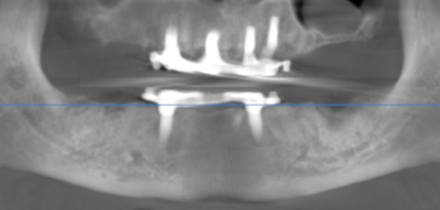

3-DIMENSIONAL VIEW

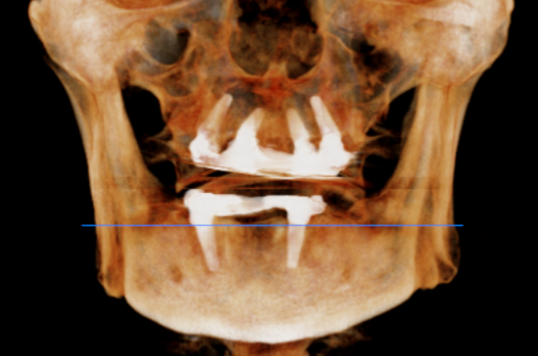

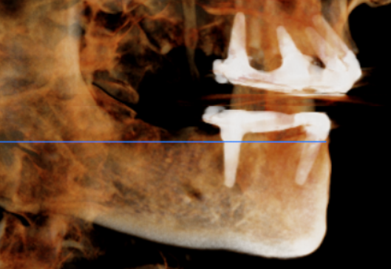
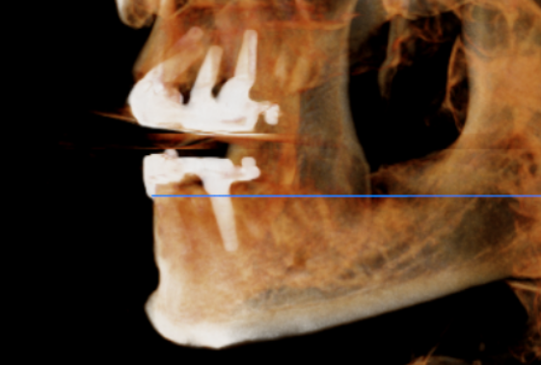

CROSS SECTIONAL VIEW

15 region | 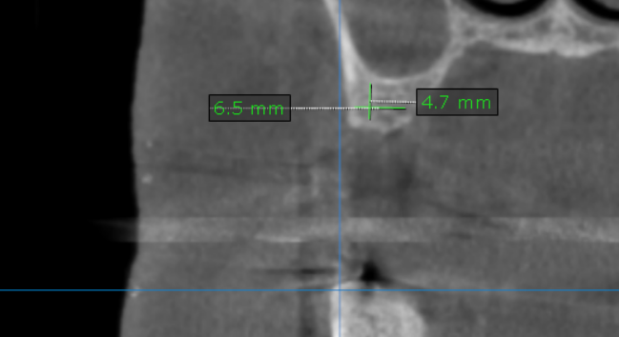
16 region | 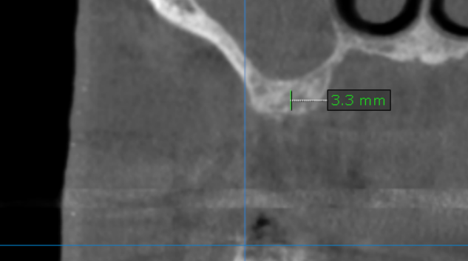
17 region | 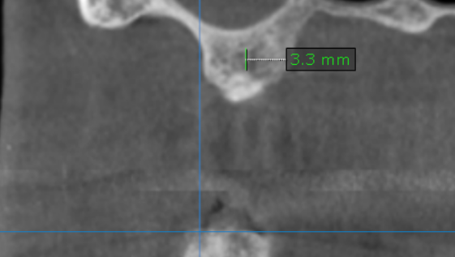
25 region | 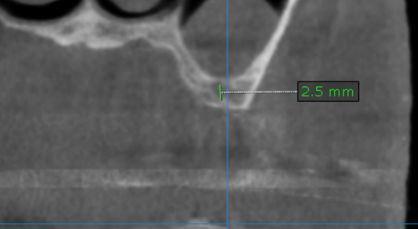
26 region | 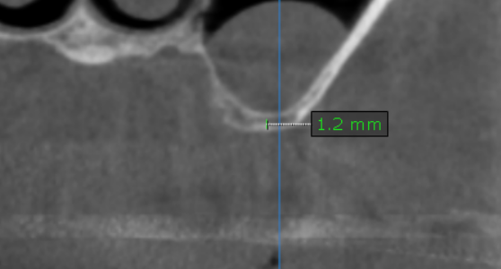
27 region | 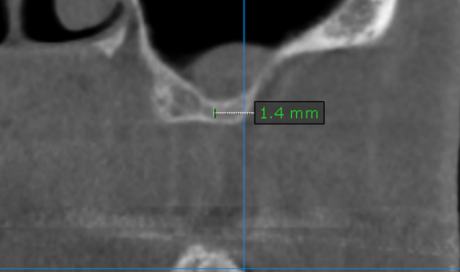
35 region | 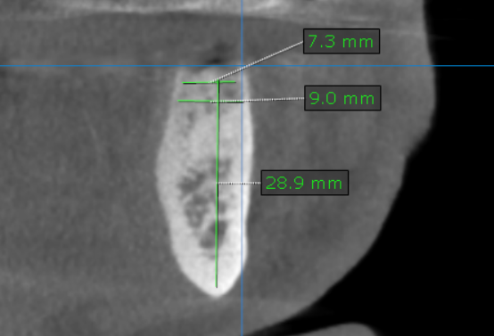
36 region | 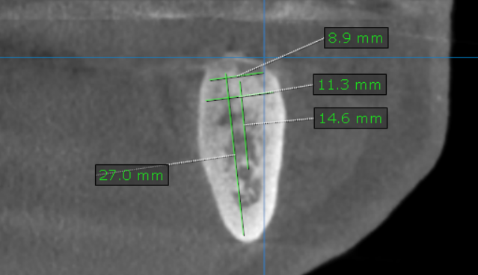
37 region | 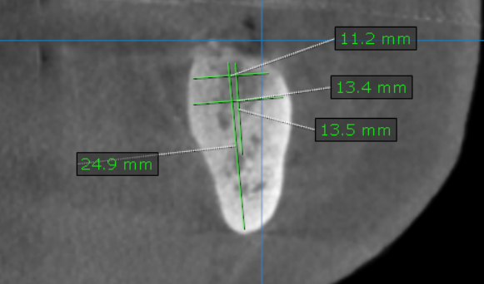
45 region | 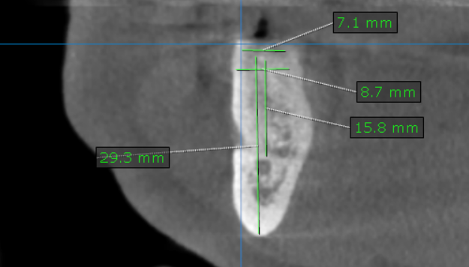
46 region | 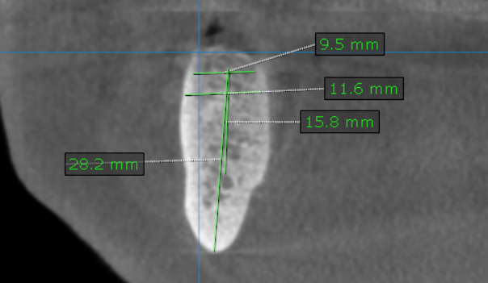
47 region | 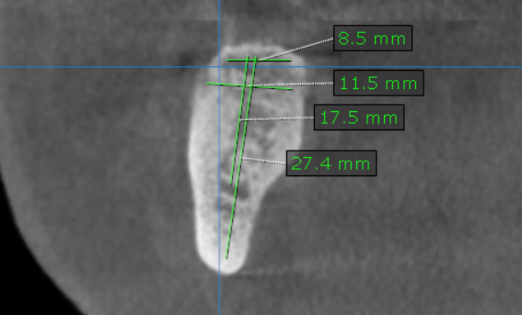

**** End of report ****

